“What Constructional Profiles Reveal About Synonymy and Metaphor: A Case Study of Russian words for ‘sadness’”

Abstract
What can constructions tell us about the meaning of words? Are semantic phenomena such as synonymy and metaphor reflected in the syntactic behavior of a word? Can these relations be demonstrated on the basis of quantitative data? This article presents a corpus-based study in an attempt to answer such questions. It is offered in the spirit of developing empirical methods in cognitive linguistics “that try to ground linguistic analysis on the firm basis of objective observation” (Geeraerts 2005: 165). This study examines the constructional profile patterns of six Russian nouns denoting ‘sadness’ extracted from corpus data, plus the patterns of twelve other nouns, both concrete and abstract, which are analyzed for comparison. “Constructional profile” refers to the distribution of relative frequencies of constructions associated with a given word.

Key words: metaphor, synonymy, construction grammar, Russian, emotions

1. Introduction
Emotion words in general and Russian emotion words in particular have attracted the attention of cognitive linguists. The container metaphor is often cited as the most common conceptual metaphor relevant for the domain of emotions (Lakoff & Johnson 1980: 31-2, Kövecses 2001: 37), and constructions with verbs involving ‘entering into’ (usually by means of ‘falling’ or ‘sinking into’) an emotional state have been associated with ‘sadness’ nouns in both Russian and Polish (Wierzbicka 1998: 11). The present work adds to the existing literature by undertaking an empirical study of Russian emotion terms.
Previous relevant research in cognitive linguistics includes work on construction grammar (primarily Goldberg 1995, 2006), collostructional analysis (Stefanowitsch & Gries 2003, 2005), behavioral profiles of synonyms (Atkins 1987, Hanks 1996, Divjak & Gries 2006), and metaphorical pattern analysis (Stefanowitsch 2006 a&b, Svanlund 2007). The present work builds on all of these models, extending them in various ways. Whereas most work on constructions is centered on verbs in languages lacking case (mostly English), the data presented here focuses on nouns in a case-marking language (Russian), thus expanding the repertoire of construction grammar.
In a case-marking language such as Russian, theoretically any noun has an equal capacity to appear in any case, and those case markings have an equal capacity to appear with or without any of the prepositions associated with them. However, the data in this study suggest that the distribution of case/preposition construction frequencies, here referred to as a constructional profile, is different for different nouns, and indeed it is likely the case that no two nouns share an identical constructional profile. This means that constructional profiles can be used to compare the “closeness” of synonyms (and antonyms), as well as to compare the behavior of metaphorical source and target domain lexical items.
This study focuses on the constructional profiles of six Russian words for ‘sadness’: grust’, melanxolija, pečal’, toska, unynie, and xandra. There are seventy constructions with various combinations of preposition and case for noun phrases in Russian, but only a few are relevant for any given noun. Our study uses corpus data to establish the constructional profiles of the Russian ‘sadness’ words, which can then be quantitatively compared to the construction profiles of other words. There are clear patterns among the ‘sadness’ synonyms. There are also clear parallels between the ‘sadness’ synonyms and their antonyms, the ‘happiness’ nouns likovanie, naslaždenie, radost’, udovol’stvie, vostorg, providing evidence that antonyms are indeed semantically very close to each other.
A quantitative analysis of constructional profiles makes it possible to explore the validity of the CONTAINER metaphor for emotions. Jama ‘hole, pit’ is a source domain noun, providing a standard for comparing the target domain emotion words. Three ‘sadness’ nouns, melanxolija, unynie, and xandra, show clear parallels to jama ‘hole, pit’ in their constructional profiles, though they also diverge from that pattern in a meaningful way. Comparison of constructional profiles shows that only part of the structure associated with a source domain container is conventionally mapped to the target domain of emotions in Russian: getting into a container and being in a container are mapped, but getting out is not mapped. In Russian, a different metaphor, based on healing from disease, is more often used to understand how emotional states are concluded, invoked by the construction ot + Gen ‘away from’.
This article is organized as follows. Section 2 provides a theoretical foundation by defining relevant terms and positioning them within the traditions of cognitive linguistics and construction grammar. This section additionally provides an overview of relevant facts of Russian grammar. Section 3 presents the methodology and illustrates it with an example analysis. Section 4 examines the constructional profiles of the six ‘sadness’ synonyms, the constructional profiles of antonyms meaning ‘happiness’, as well as some words that are neither synonyms nor antonyms for comparison. Metaphor is the topic of section 5, where the constructional profiles of source domain and target domain nouns are compared. Conclusions are presented in section 6, which is followed by two appendices offering illustrative examples of case usage (Appendix A) and raw data for the nouns analyzed in the article (Appendix B).

2. Definition of terms and relevant grammatical facts of Russian
This section will define the terms construction and constructional profile relative to standard concepts in cognitive linguistics and construction grammar. In addition, some basic facts of Russian case use are provided.

2.1 Construction
We use the term construction in a way that is compatible with current usage in cognitive linguistics, in other words as used by Langacker (1987, 1990, 1991), Croft (2001), Goldberg (1995 and 2006), and Fillmore (Fillmore 1985, Kay & Fillmore 1999, Fillmore et al. forthcoming). Although some differences in the usage of construction among these scholars must be acknowledged (cf. Langacker 2003 and Goldberg 2006: 213-226), these points are less relevant to our analysis than the ideas that all three share, so we will focus on their common ground, ignoring minor discrepancies.
Our definition of construction is: “a conventionalized pairing of form and meaning in a language”. This definition is closest in its phrasing to Goldberg’s (2006: 3), yet consistent in spirit with Langacker’s (1987: 58) “symbolic unit” which pairs form (phonological pole) with meaning (semantic pole). We recognize constructions as the relevant unit of linguistic analysis (Feldman 2006: 288), though constructions can be found at many levels of complexity, and, as Goldberg (2006: 18) says, “it’s constructions all the way down”. For the purposes of this article, we will select the level of complexity represented by Russian noun phrases, with their associated case marking and prepositions. These noun phrases represent “conceptual archetypes” (Langacker 1991: 294-5), also known as “recurring semantic prototypes” based on “universal functional pressures” (Goldberg 2006: 16, 224). However, the constructions themselves are language-specific (cf. Croft 2001).
Our constructions are of the form: “[(preposition) [noun]_{case}]”. This formula states that case is obligatory in all constructions, but only some constructions also involve a preposition. The formula contains a slot that can be filled by a noun (underlined), while keeping the identity of the case (and preposition, if present) constant. This is equivalent to stating that the noun elaborates (Langacker 1987: 68; 304-5) the construction that is schematically specified by the case and preposition by filling the placeholder for the noun. Because the noun is the variable part of the construction, we often use a short-hand formula, stating only the fixed components: “case” or “preposition + case”. For each construction, this form is paired with a meaning that is only partially determined by the meanings of the components. The meaning of each construction is emergent (Langacker 1991: 5-6, 534; Bybee & Hopper 2001: 2, 10; MacWhinney 2001), motivated by the patterns of uses over the various nouns that appear in the construction, and also by the larger (clause-level) constructions that these noun phrase constructions appear in. Our analysis gives empirical substance to the claims made by Raxilina (2000) that Russian nouns can serve as constructional cores, and that the meaning of a noun is partly a function of the constructions it is found in. This analysis is also in harmony with the traditions of the Moscow semantic school (Apresjan 1995, Mel’čuk 2001) and the school of “Logical Analysis of Language” (Arutjunova 2007), which likewise assert that combinatorial properties of nouns reveal the cognitive structure of nominal semantics.
To summarize, we will focus on noun phrase constructions that specify case with or without a preposition. These are conventional constructions that are specific to Russian, and are paired with meanings that are motivated by, but not strictly predictable from the meanings of the component cases and prepositions.
Collostructional analysis typically takes the construction as the point of departure, but in this work we examine individual words and the distribution of constructions each is associated with, a reversed perspective suggested among opportunities for future research by Stefanowitsch & Gries (2003: 237). This perspective makes it possible to compare the behavioral profiles of words, as demonstrated by Divjak & Gries (2006) and Gries & Divjak (forthcoming) and Divjak 2006, who use an ID tagging method to compare synonymous verbs. In this study we focus instead on nouns and their grammatical case markings, plus the presence or absence of a preposition.

2.2 Constructional profile
A constructional profile is a property of a word. Constructional profile can be defined as: “the relative frequency distribution of constructions that a given word appears in”. In other words, let us say that the word lexeme appears in constructions C₁…C_{n}. In order to arrive at lexeme’s constructional profile, it is necessary to gather data on the frequency of lexeme’s occurrence in each of the constructions C₁…C_{n} and to compare those frequencies as percentages of lexeme’s overall occurrence (a.k.a. the “reliance” metric, cf. Schmid 2000: 54). Lexeme’s constructional profile is thus a chart showing that lexeme occurs X% of the time in construction C₁, Y% of the time in construction C₂, Z% of the time in construction C₃, etc. through C_{n}. Each percentage indicates how frequent the given construction is for the given word in a particular corpus, and the aggregate of percentages indicates the degree to which that noun is associated with that particular pattern. Constructional frequency data is extracted from corpora that are designed to reflect the parameters of a given language. In practice, there are often many constructions associated with a given word, and most occur at very low frequencies. Based on the data in our study, there are usually only 6-10 constructions that are needed to accurately represent the constructional profile of a word.
Constructional profiles can be likened to flavors. Flavors are composites of the values of the variables that our tongue and nose can perceive (Churchland 1995). In other words, a flavor such as apricot is a collection of peaks with various values that differs from other collections of peaks such as the one associated with peach. A word’s constructional profile is probably unique and representative of its meaning, though there are certainly other factors, such as: the embodied contexts in which a word is used, the knowledge structures (frames; cf. Fillmore 1982) it is associated with, its collocational patterns, and transparent etymological or derivational relationships to other words in the lexicon.
It is unlikely that speakers store all uses of given words and constructions, but there is evidence that people use generalizations about the frequency of word use (Goldberg 2006: 62, 46). These generalizations can serve as the basis for creating abstract schemas for constructions, establishing correlations between form and meaning. Goldberg (2006: 104-119) argues that constructions have strong associations with meaning by virtue of their advantages in terms of both cue validity and category validity. Cue validity refers to the likelihood that a given meaning will be present given the presence of a certain item. In a study comparing the cue validity of words (verbs) with constructions, Goldberg found that words and constructions have roughly equal cue validity, which means that knowing that a linguistic unit contains a given word gives you about the same predictive information as knowing that a linguistic unit occurs in a given construction. However, because there are far fewer constructions than lexical items in a language, constructions are far more available in terms of determining meaning. Category validity is the likelihood that a certain item will be present when the meaning is already given. In Goldberg’s studies the category validity of constructions is found to be far higher than that of words (verbs). In other words, if you know that a unit expresses a certain meaning, it is much easier to predict what construction might be present than to predict what word the unit might contain. Goldberg has thus empirically established the connections between constructions, frequency and meaning. Although Goldberg’s work focuses on verbs as construction cores, we argue that her conclusions are applicable to noun phrases, particularly in languages that mark case.
It is tempting to consider a possible relationship between constructional profiles and entrenchment, given assumptions that have been made about increases in neural connections as a function of frequency (Langacker 1987: 59-60, 100, 380; Langacker 1991: 45, Bybee & Hopper 2001: 9; Taylor 2002: 276; Dąbrowska 2004: 213, 223; Feldman 2006: 105). This connection is expressed most explicitly in Schmid’s (2000: 39) From-Corpus-To-Cognition Principle: “Frequency in text instantiates entrenchment in the cognitive system”. Some recent work (Schmid 2007, Schmid forthcoming, Gilquin 2007a&b) has pointed out that corpus frequency may be an imperfect measure of entrenchment. Given these reservations, we remain agnostic and make no claims concerning a connection between constructional profiles and entrenchment.

2.3 Case in Russian
Blake (1994: 1) defines case as “a system of marking dependent nouns for the type of relationship they bear to their heads”. “Heads” here refers to verbs at the clause level, and adpositions or other nouns at the phrase level. In our study we focus only on “bare” case (without a preposition) uses that indicate a relationship to a verb, and prepositional case uses that create adverbials. In other words, the relevant uses of case here entail the marking of relationships to verbs, either directly as arguments or more peripherally as adverbials. We argue that whereas in English one must look at the verb and its construction in order to make sense of the role of nouns in a clause, in a case language much of that information is encoded directly on the noun phrases themselves. The noun phrase constructions of Russian have unique meanings, some of which are further disambiguated at the level of the clause.
Feldman (2006: 260-1, 318) notes that, aside from intonation and gesture, there are three mechanisms for conveying semantic relations in language, and they are: 1) words, 2) word order, 3) word form (inflection). Feldman goes on to point out that work in linguistics has been preponderantly based on English, and “this helps explain why much less attention has been paid to morphology as a source of meaning than to words and word order”. Feldman’s comment about the bias toward non-inflected languages is also applicable to work in construction grammar, though there are some notable exceptions (Barðdal 1999 & 2006, Fried 2005). Goldberg (2006: 5, 10) acknowledges that “[a]ll levels of grammatical analysis involve constructions” and that “[a]n actual expression typically involves the combination of at least half a dozen different constructions”. She also recognizes that constructions can profile units other than verbs (Goldberg 2006: 221).
Although even in Russian verbs are the most crucial constructional component at the clausal level, clauses also contain noun phrases which are well-specified constructions in their own right. The morphological marking on Russian nouns makes them much more information-rich in terms of specifying what construction is present than English nouns. Kempe & MacWhinney (1999) have established based on psycholinguistic data that case in Russian has high cue validity and high cue availability, even relative to another case-marking language (German), and that Russian speakers do rely on case in on-line sentence interpretation. On this basis we assert that Goldberg’s claims for the relationships between constructions and verbs in English are applicable to nouns in Russian as well.
Case in Russian is obligatory and concordial, marked on nouns, pronouns, adjectives, numerals and determiners. When a language marks case, word order is usually relatively free; there are “defaults” for word order, but word order does not determine syntactic roles and in principle, any order of noun phrases and verb forms is possible.
Russian has six cases marked by means of synthetic inflectional endings: Nominative (Nom), Accusative (Acc), Dative (Dat), Instrumental (Inst), Genitive (Gen), and Locative (Loc). Since every noun phrase obligatorily expresses one of these cases, a noun phrase will always carry with it the syntactic and semantic information associated with the given case. The Russian cases present a complex system with dozens of submeanings. However, Janda and co-authors (Janda 1993, 1999, 2000, 2002a-d, 2004, forthcoming; Janda & Clancy 2002; Divjak & Janda forthcoming) have established that each Russian case forms a coherent semantic whole. A given Russian case is associated with 1-4 prototypical meanings based on concrete embodied experience, and other meanings are motivated as metaphorical and metonymical extensions from the prototype(s). The following brief overview necessarily compresses a mass of detail and focuses primarily on the meanings that are directly relevant to the study in this article. In keeping with the above-cited research on Russian case, we will assume that case is the primary marker of the meaning of a syntactic relationship and that prepositions, where present, elaborate those meanings, forming a composite structure that shows conceptual integration (Langacker 2003).
Nominative: The primary use of this case is for the subject of the verb (where present). In addition, the Nominative can be used for the purposes of naming and calling, and to state a stable identity in copular constructions. The Nominative provides the least information in terms of constructions, and is not very relevant to our study.
Accusative: This is the case of destinations, be they of physical motion, metaphorical motion, or merely the energy of an action, as we see in the prototypical direct object, which is marked with the Accusative (cf. also Langacker 1991: 285, 2000: 13-14). This study focuses on the use of the v + Acc ‘into’ prepositional phrase which designates a path whose destination is a container.
Dative: The Dative has three overlapping roles, as the receiver of an object, the experiencer of an event, or a competitor that may be on an equal footing with or superior to a nominative subject, causing the latter to submit to the Dative-marked entity. Crucial to the Dative is the ability to react, to serve as a potential subject. Since most of the nouns in our study denote abstractions, this case is not of central importance in our study.
Instrumental: An Instrumental entity is a peripheral accessory to something else, be it a verb or a noun. This case can mark a conduit for the action of a verb, which is in the physical domain a path of progression, the way something goes. In the metaphorical domain it is a way to do things, a means by which something is accomplished, or the agent of a passive. Metaphor and metonymy further motivate the use of the Instrumental for verbs denoting control, possession and positive/negative evaluation of objects. In relation to a noun, the instrumental can specify a label through which another item is accessed. In the presence of prepositions, the Instrumental can mark a peripheral adjunct (a comitative relationship) or a positional relationship relative to the periphery of a landmark (such as above, below, behind, in front of, between). In our study the most relevant uses are the bare Instrumental with verbs to indicate means (instruments) and objects positively/negatively evaluated, along with the prepositional use of s + Inst ‘with’ to mark an adjunct accompanying an argument of the verb.
Genitive: The Genitive often serves as a mental address for something else. It is a backgrounded item that yields the focus of attention to something else which exists or maneuvers in its proximity. The Genitive can be the whole of which something is a part (motivating quantitative and adnominal uses), the source or goal of another item, or (by metonymy) a reference point for locating another item. The Genitive is used with a large number of prepositions, but two are most relevant for our study, namely bez + Gen ‘without’ and ot + Gen ‘away from’. The latter construction is frequently employed in metaphorical domains to designate causes and reasons.
Locative: This case is always elaborated by a preposition in modern Russian, designating locations in space, time or other metaphorical domains. Five prepositions are used with the Locative case, and the most relevant one to our study is v + Loc ‘in’, which marks locations that are containers.
The constructions most relevant to this study are: v + Acc ‘into’, v + Loc ‘in’, Inst (bare Instrumental), s + Inst ‘with’, bez + Gen ‘without’, and ot + Gen ‘away from’. This list was arrived at based upon the overall frequencies of constructions in which the ‘sadness’ words appeared. These constructions are illustrated with corpus examples in Appendix A.

3. Methodology and Sample Analysis
The noun phrase constructions of Russian can be unambiguously identified based on objective formal criteria, namely case endings and prepositions. Since constructional profiles represent the relative frequencies of constructions, a database is needed to establish these frequencies. Both the corpora from which data were extracted and the methodology used in the process are described below, illustrated by an example of the results and how they are presented in this article.

3.1 Corpora
Our study extracted data from two corpora, the Russian National Corpus (http://www.ruscorpora.ru; henceforth RNC) with over 120 million words, and the Biblioteka Maksima Moškova (http://lib.ru/; henceforth BMM) with over 600 million words. Both corpora consist exclusively of authentic texts produced by and for native speakers, and their contents have been edited for typographical accuracy. One major difference between the two corpora is that the RNC has been designed to reflect a greater range of genres, including samples of popular written and spoken Russian, whereas the BMM is literally an electronic library of primarily literary works. It turns out, however, that the difference in composition of the two corpora does not have much of an effect on the frequencies of noun phrase constructions. Similarity in constructional frequencies across the two corpora was established on the basis of two pilot studies.
In the first pilot study, constructional frequencies were measured for the word skorb’ ‘grief’. This study compared data for the first 1000 sentences containing skorb’ ‘grief’ in the BMM with the first 500 sentences containing the same word in the RNC. The difference in frequencies between the two corpora never exceeded 6%, and the overall average difference was 4%. This difference was comparable to the difference between the first 500 sentences containing skorb’ ‘grief’ and the second 500 sentences with that word within the BMM, where the differences did not exceed 8% and the overall average difference was again 4%. In other words, the difference between the two corpora was approximately the same as the differences between consecutive samples within a single corpus. An analogous comparison was carried out for the word ispug ‘fright’, based on 200 sentences with this word from the RNC and 400 sentences from the BMM. Again, the difference never exceeded 7% and was on average 4%. These comparisons mean that data from the two corpora could be used to supplement each other without disturbing the validity of the data, which was fortunate especially for the collection of data on low frequency words such as xandra ‘sadness’. These comparisons also establish the fact that there was no appreciable increase in precision obtained by analyzing more than 500 sentences for a given word. The first 500 sentences in BMM gave virtually the same results as the next 500 sentences from the same source, and this result was also not significantly different from either the first 500 in the RNC or the total of 1500 sentences from both sources. Based on these pilot studies, it was determined that the first 500 sentences containing a given word provide a sufficient sample size, and that the source (RNC, BMM, or both) was not a relevant factor.

3.2 Data extraction
500 sample sentences were extracted for each word in the study in order to determine each noun’s constructional profile. The pertinent noun phrase construction (the one containing the queried word) in each sentence was analyzed manually, and the case of every queried noun was recorded along with the identity of any associated preposition. The analyses were conducted by students in the Linguistics Department at the University of Kazan’. In principle it would be possible to have the analysis done by machine, but there is no automatic parser of Russian at present with sufficient accuracy. This does not mean, however, that any subjective judgments were involved. On the contrary, the identity of the case a noun appears in is unambiguous in Russian despite a small amount of paradigmatic syncretism. In rare instances where there might be some confusion, a native speaker can easily recover the case by asking the relevant Who?/What? question, which gives a unique answer for each case (Kto?/Čto? for Nominative, Kogo?/Čto? for Accusative, etc.). The task was simple and objective, the analyses were carried out by linguists in training on their native language, and the results were virtually error-free.
Once the data was collected and analyzed, the scope of the search could be narrowed down to target the most valuable results. A given noun can usually appear in a fairly large number of constructions, but most of these are of such low frequency (<1%) that they contribute little information about the noun’s overall constructional profile. On the other hand, there are some constructions that appear in fairly high frequencies (e.g., Nominative subject, adnominal Genitive), but do not give much information about aspects of a noun’s constructional profile because virtually any noun can appear in those constructions. The search was thus narrowed to those sentences in which the noun appeared as a non-subject argument of the verb or as an adverbial. This made it possible to focus on the noun phrase constructions that were most relevant to the verb. Thus from the original 500 sentences, only the sentences where the queried word appeared as a non-Nominative argument or adverbial were analyzed further, and all frequencies are based upon the remaining number of sentences for a given word (usually in excess of 70% of the original 500). From these data it is possible to pinpoint which constructions are most representative of a word’s constructional profile to present their frequencies.

3.3 Sample analysis
The methodology can be demonstrated using the Russian word stul ‘chair’. The first 500 sentences containing stul ‘chair’ were culled from the BMM. Of these, 358 sentences (72%) contained uses of the word as a non-Nominative argument or adverbial. Here is the raw data on the absolute numbers of attested constructions found in these 358 sentences.

Table 1: Attestations of constructions containing Russian stul ‘chair’
construction | number of sentences | construction | number of sentences
na + Acc ‘onto’ | 108 | ot + Gen ‘away from’ | 2
na + Loc ‘on’ | 82 | Inst ‘by means of’ | 2
s + Gen ‘off of’ | 70 | v + Acc ‘into’ | 1
Acc | 64 | iz + Gen ‘out of’ | 1
k + Dat ‘toward’ | 8 | okolo + Gen ‘around’ | 1
za + Acc ‘to behind’ | 4 | iz-pod + Gen ‘out from under’ | 1
za + Inst ‘behind’ | 4 | pozadi + Gen ‘behind’ | 1
pod + Inst ‘under’ | 4 | o + Loc ‘about’ | 1
s + Inst ‘together with’ | 3 | nad + Inst ‘above’ | 1

From this raw data, we can see that four constructions account for nearly all of this word’s constructional profile, and we calculate the frequency of each construction in relation to the total number of 358 sentences. This calculation yields the following data for stul ‘chair’, reported as percentages (rounded to the nearest integer):

Table 2: Frequency of constructions containing Russian stul ‘chair’ (percent)
na + Acc ‘onto’ | na + Loc ‘on’ | s + Gen ‘off of’ | Acc | other Cs
30 | 23 | 20 | 18 | 9

This table gives a breakdown of percentages only for the constructions found to be most relevant for stul ‘chair’; data for all other constructions are presented as a sum under “other C’s”. Alternatively, this data can be plotted on a graph thus:
Graph 1:
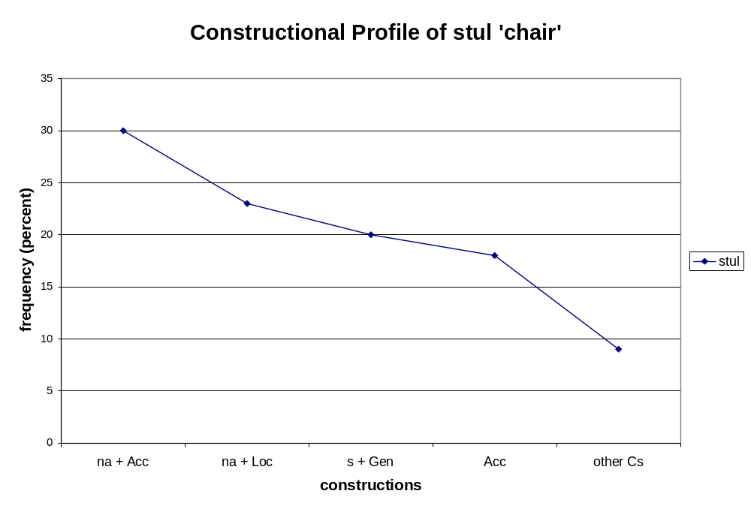

The constructional profile that thus characterizes Russian stul ‘chair’ is anything but random. Under the null hypothesis, a given noun would have the same probability of occurring in all seventy [(preposition) [noun]_{case}] constructions available in Russian grammar. The chance that nearly all of the uses would be clustered around precisely these four constructions is similar to the chance that a certain four cards would be selected from a deck of seventy cards, which is approximately 0.000001, or one in a million. A similar figure would result from this calculation for any of the constructional profiles presented in this article.
The use of graphs makes it easy to visualize and compare constructional profiles across words, and this is how most of the data is presented in this article. In the remainder of this article, charts will not present the data on the frequency of the bare Accusative (since any noun can appear as a direct object) or the “other constructions” (since this is just an aggregate sum), but will focus on the data that is most distinctive for a given word or set of words. However, all data is presented in the tables in Appendix B.

4. Constructional profiles and synonymy
The purpose of this section is to explore the idea that the constructional profile of a noun is indicative of its meaning, and that this information can be used to examine the fine-grained distinctions among close synonyms. Of course the idea that a word’s use is indicative of its meaning is not new, since it can be traced to the works of many linguists (among them Meillet, Bloomfield, and Harris, cf. Ide & Véronis 1998: 23).
Computational linguists have developed an impressive array of programs designed to detect and even “learn” how to disambiguate polysemous words and recognize synonyms (two closely related problems in Word Sense Disambiguation, WSD). The majority of work in WSD has followed Firth’s (1957: 11) maxim “You shall know a word by the company it keeps”, thus focusing on word co-occurrence data to determine word senses and their relative “distance”. Such algorithms typically look at a node word and the window of x words (for example, if x=3, the window would include three words to the left and three to the right) that surround it in all its occurrences in a corpus and then compare this measure to that of other words. A few such studies described here provide context for this article. In most WSD studies, grammatical information (syntax, morphology, word order) is not taken into account, although there is some indication that the algorithms are sensitive to grammatical facts such as word class (Burgess et al. 1998). Where grammatical information has been included, this has typically been limited to identification of part of speech (Ide & Véronis 1998: 20). Latent Semantic Analysis (LSA; Landauer et al. 1998) computes the aggregate of all the contexts that a given word appears and does not appear in and represents this as a high-dimensional “semantic space”. LSA is a significant improvement over many earlier methods which relied on dictionaries and manually-crafted semantic networks; its only input is raw text parsed into words and passages. Though LSA can mimic some human activities (synonymy and word relatedness tests), it also makes some odd judgments (e.g., that English verbally and sadomasochism are closely related). Burgess et al. (1998) offer the Hyperspace Analogue to Language (HAL), which likewise computes the statistical co-occurrence patterns of words, depicted as multidimensional scaling solutions, and one of the conclusions is that synonyms do indeed occur in the same contexts. Dagan (2000) offers another solution, one that features semi-automatic thesaurus construction procedures based on corpus statistics. Like LSA and HAL, Dagan’s model is based entirely on word co-occurrence vectors; it is claimed that there is no adequate parser that would make it possible to include grammatical information (Dagan 2000: 462). Turney (2002, 2005) has worked on two further options, Pointwise Mutual Information (PMI) and Latent Relational Analysis (LRA), which have been tested against items from the TOEFL and SAT tests, respectively. Though the LRA has a grammatical component, both are based primarily on word co-occurrence data.
Kilgarriff (1997), Ide & Véronis (1998), Kobricov (2004), and Budanitsky et al. (2006) provide overviews of the trajectory of research in WSD. Their conclusions are rather disappointing, despite the variety and computational sophistication of the models devised. Nouns in particular have been most resistant to WSD (Ide & Véronis 1998: 21). Both Kilgarriff (1997) and Ide & Véronis (1998) make the point that despite computational advances, one of the crucial theoretical issues, namely defining what a word sense is, remains unresolved, and this has severely hampered progress, particularly since the underlying assumption is usually that word senses are discrete and independent of corpora. Kilgarriff (1997) and Budanitsky et al. (2006) cite work on polysemy and metaphor (specifically Apresjan 1974, Lakoff & Johnson 1980 and Lakoff 1987), arguing that if word senses do not behave as classical categories, and can also be influenced by ad-hoc categories, then it is very unclear how such “semantic relationships could be quantified in any meaningful way, let alone compared with prior quantifications of the classical and non-classical relationships” (Budanitsky et al. 2006: 45). Ide & Véronis (1998: 27) conclude that “relatively little progress seems to have been made in nearly 50 years” and “it appears that we may have nearly reached the limit of what can be achieved in the current framework”. Kobricov’s (2004) evaluation is nearly identical, stating that even when good accuracy has been achieved, it applies only to a very small group of words, and that the best descriptor for the state of the art is “stagnation”.
We offer a fresh perspective, facilitated by the fact that Russian is a case-marking language. We define our comparisons syntactically, in terms of constructions, instead of lexically, in terms of the meanings of collocated words. Instead of seeking discrete senses, we examine the relative frequencies of grammatical constructions, which, as shown above, turns out to be a fairly stable metric for a given noun.

4.1 Six Russian words for ‘sadness’
Although all six Russian words that form the core of this study can be translated as ‘sadness’ or ‘melancholy’, and they are certainly synonyms, there are clearly also differences among them, which makes it possible for speakers to produce sentences like this one:

Uxodiš’, i ja gljažu vsled tebe s grust’ju, no bez toski.
[Depart, and I-Nom look following you-Dat with sadness-Inst, but without sadness-Gen.]
‘You leave and I watch you go with sadness_{grust’}, but without sadness_{toska}.’

As this example suggests, sadness_{grust’} is the kind of sadness that is associated with grief, whereas sadness_{toska} is the sadness associated with yearning. The entries in Russian-English dictionaries list about a dozen “equivalents” for each Russian ‘sadness’ term; here we list just a few to give the reader some appreciation for both the similarities and the differences: grust’ ‘grief, sorrow, heartsinking’; melanxolija ‘dejection, the blues, pensiveness’, pečal’ ‘grief, mourning, sorrow’, toska ‘grief, yearning, depression’, unynie ‘despondency, dejection, depression’, and xandra ‘the blues, distemper, mope’. Russian synonym dictionaries struggle with this group of words. Most often, grust’, pečal’, and toska are placed in one group, characterized as denoting the ‘unpleasant feeling one has when one wants something one doesn’t have and doesn’t believe one can get it’ (Apresjan et al. 1997). Melanxolija and xandra are listed as another group, and then there is disagreement over what to do with unynie. Apresjan et al. 1997 groups unynie with pečal’, Aleksandrovna 1989 puts unynie with xandra, and Evgen’eva 2001 puts unynie with both grust’ and xandra, claiming that it has two meanings.
The constructional profiles of these words both confirm the overall pattern suggested in synonym dictionaries and explain why there is a problem with unynie. Graph 2 shows the relative frequencies (in percentages) of the constructions that were found to be the most frequent overall for the ‘sadness’ nouns: v + Acc ‘into’, v + Loc ‘in’, Inst ‘by means of’, s + Inst ‘together with’, bez + Gen ‘without’, and ot + Gen ‘away from’.

Graph 2:
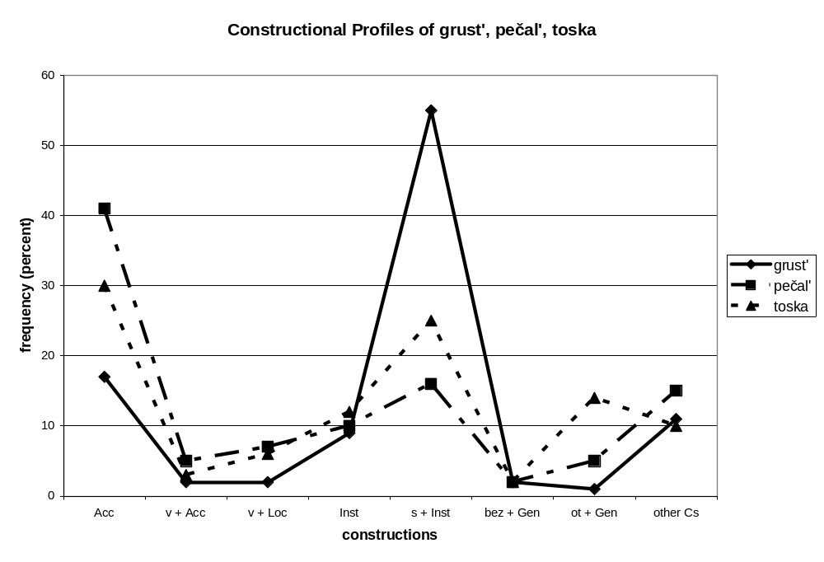

Graph 2 shows the overall similarity of grust’, pečal’ and toska, with a peak at s + Inst ‘together with’, lower values at Inst ‘by means of’, v + Acc ‘into’, and v + Loc ‘in’. This graph also highlights differences between the three words. For example, although all three words have a peak s + Inst, grust’ has by far the highest, with that construction representing over 50% frequency. Use in the ot + Gen ‘away from’ construction differs, with a peak for toska, a low value for pečal’, and almost no use for grust’.

Graph 3:
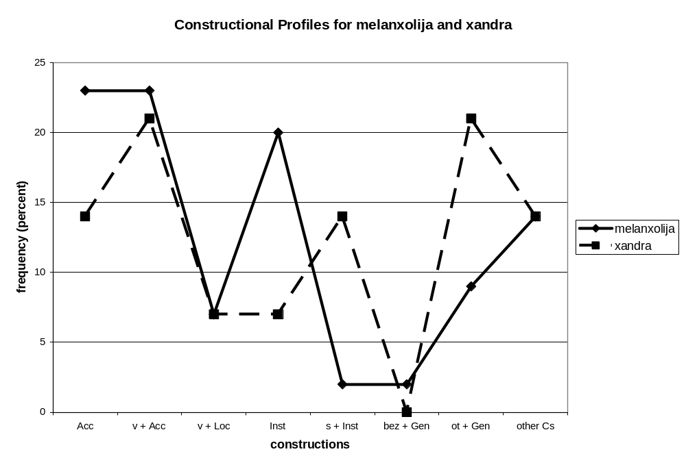

Graph 3 compares melanxolija and xandra, showing that they share high values for v + Acc ‘into’, moderate values for v + Loc ‘in’, low values for bez + Gen ‘without’, but higher values for ot + Gen ‘away from’. In constructions with the Instrumental case their frequency values differ, with melanxolija showing a peak at Inst ‘by means of’ and xandra showing a peak at s + Inst ‘with’.

Graph 4:
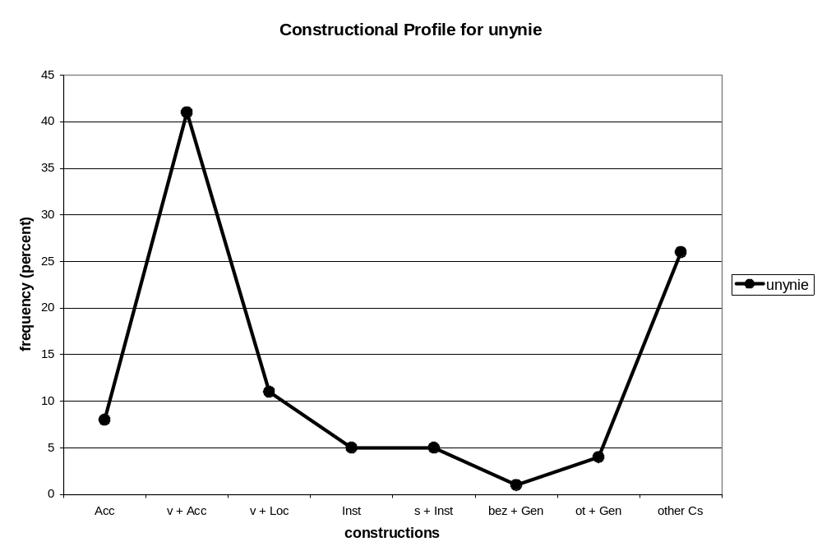

Graph 4 shows that unynie does indeed behave differently from the other ‘sadness’ words, with a very high peak for v + Acc ‘into’, a moderate value for v + Loc ‘in’ and low values elsewhere.
The constructional profile graphs show that it is possible to quantify the similarities and differences among near synonyms, making it easy to point out exactly which constructions are most relevant. These graphs also confirm an important tenet of cognitive linguistics: the assumption that difference in form entails difference in meaning, with the corollary that there are no perfect synonyms. As we see here, even among very near synonyms, there are differences in constructional profiles, and indeed it is very unlikely that any two words, no matter how closely related, are identical in their constructional profiles.
Section 5 connects these comparisons of peaks and valleys with the metaphorical behavior of the nouns and their meanings, so that issue is not discussed in detail here, but we can note that the constructional profile graphs present roughly three conceptual groupings. The first two constructions, v + Acc and v + Loc, describe entering into and being in a place (here an emotional state); they can be summed up as the ‘in/into’ relations. The next three constructions, Inst, s + Inst, and bez + Gen, can be summed up as the ‘with/without’ relations. And the last construction, ot + Gen, describes an ‘away’ relation. These groupings can help us to sort through the patterns in the graphs. The first three nouns, grust’, pečal’ and toska, are the most similar overall, with parallel frequency distributions for both ‘in/into’ relations and ‘with/without’ relations; they differ most in their use of the ‘away’ relation. Melanxolija and xandra are similar to each other in their use of ‘in/into’ relations (where they also differ from the first three nouns) and the ‘away’ relation, and differ from each other in the ‘with/without’ relations. Unynie is similar to melanxolija and xandra in the ‘in/into’ relations and (to a far lesser degree) the ‘away’ relation, and shows marginal similarity to pečal’ and toska in the ‘away’ relation. However, unynie is quite flat in its use of the ‘with/without’ relations, and in this way departs from all the other ‘sadness’ nouns which have some peak in that group.
The constructional profile data confirm the introspective analyses presented above, and offer greater precision, clearly motivating the grouping of grust’, pečal’ and toska as opposed to melanxolija and xandra, as well as the quandary over unynie. Grouping unynie with pečal’ and xandra is, however, better motivated than grouping it with grust’.
For the purposes of comparison, antonyms and unrelated words are presented in the following two subsections.

4.2 Five Russian words for ‘happiness’
Antonyms are words that are virtually identical to each other in terms of what domain they refer to and what they profile within that domain, but have opposite values for some part of their meaning (Croft & Cruse 2004: 164-192). Both ‘sadness’ and ‘happiness’ are states involving human emotions evaluated on a scale of well-being, so their meanings are in many ways similar. In Russian, it turns out that the same set of constructions is most relevant for both groups of synonyms, making it very easy to compare these groups of nouns.

Graph 5:
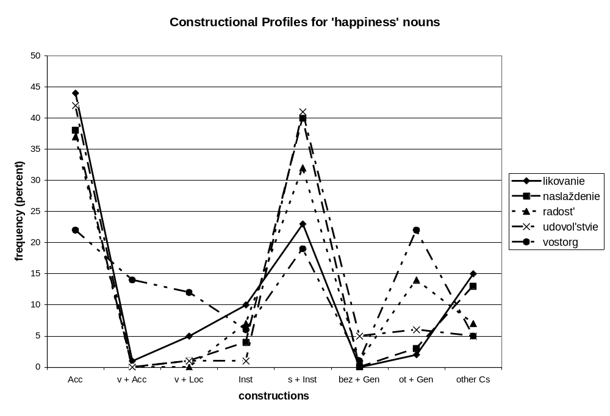

As a group, the ‘happiness’ nouns are fairly similar to the first group of ‘sadness’ nouns, with the exception of vostorg, which is an outlier. The other four ‘happiness’ nouns share many characteristics found with grust’, pečal’, and toska: the main peak is at s + Inst ‘with’, with moderate values for Inst ‘by means of’ and various values for ot + Gen ‘away from’. Vostorg shares the peak at s + Inst ‘with’, but has a higher peak with ot + Gen ‘away from’ and stronger frequencies for the ‘in/into’ relations. Overall, vostorg shows a pattern more similar to xandra, as we see in Graph 6. While these two nouns differ somewhat in their use of the ‘in/into’ relations, otherwise, they show strong parallels.

Graph 6:
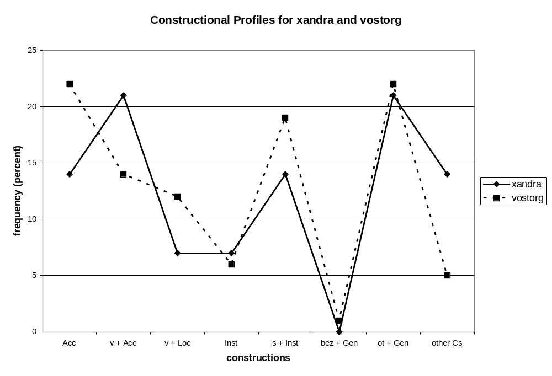
Analysis of what these patterns mean in terms of metaphor appears in Section 5. At this point it is necessary to examine the constructional profiles of nouns that are neither synonyms nor antonyms of ‘sadness’ in order to gain more perspective on what this means of comparison can provide.

4.3 Two unrelated words in Russian
The purpose of Graph 7 is merely to show that a random group of words is unlikely to show any pattern. This graph compares the constructional profile of one of our ‘sadness’ terms, pečal’, with the following: stul ‘chair’, a concrete inanimate noun; utka ‘duck’, an animate noun; and mečta ‘dream’, an abstract noun. The data are incommensurate in two ways. The first important difference is in the selection of constructions that constitute the constructional profiles of these nouns. Whereas only six constructions were sufficient to represent the constructional profiles of all the ‘sadness’ and ‘happiness’ nouns, ten constructions are needed to capture the relevant data for these four nouns, because each noun has a different set of constructions that characterize its constructional profile. For pečal’ ‘sadness’ the relevant constructions are v + Acc, v + Loc, Inst, s + Inst, bez + Gen and ot + Gen. For stul ‘chair’ the relevant constructions are na + Acc, na + Loc, and s + Gen (plus a 1% value for s + Inst). For utka ‘duck’, we get data for v + Acc, Inst, s + Inst, na + Acc and Dat. Mečta ‘dream’ shows up in v + Acc, v + Loc, Inst, s + Inst and ot + Gen. Though there are some overlaps in these selections, the actual frequencies are very different, as shown in Graph 7.

Graph 7:
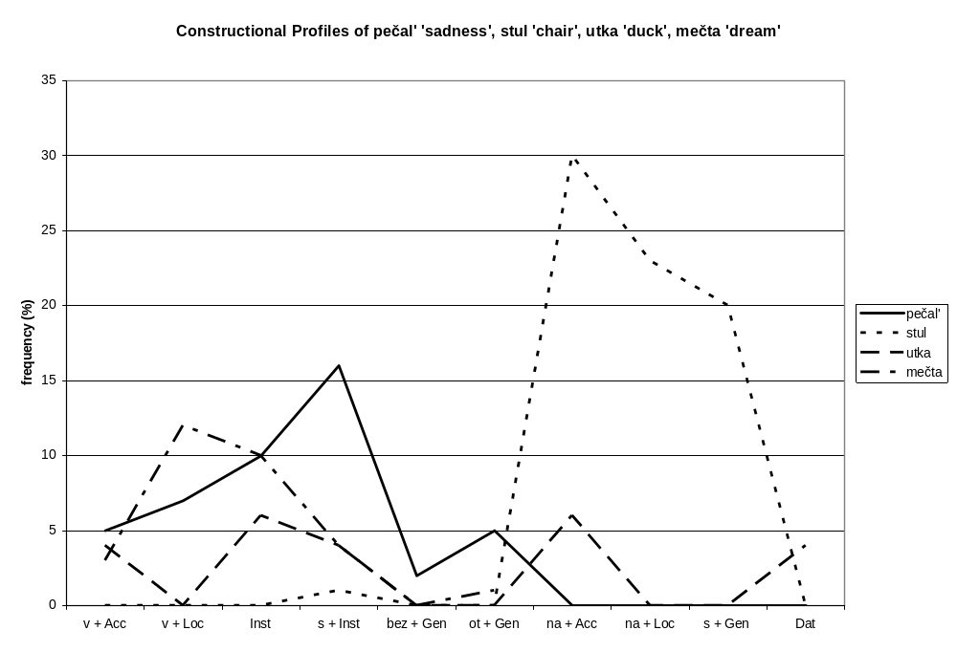

5. Constructional profiles and metaphor
Research on metaphor has established a number of basic facts (Lakoff & Johnson 1980, Lakoff 1987, Johnson 1987, Kövecses 2001). We know that metaphor can be described as novel or conventional, that conventional metaphor is an extremely pervasive phenomenon, and that conventional metaphor plays an essential role in the understanding of abstract concepts. Ontological metaphor (Lakoff & Johnson 1980: 25-32) is a cognitive strategy that makes it possible for people to conceptualize abstractions as physical entities (usually objects, substances, or locations). Metaphor is defined as a mapping from a source domain (usually grounded in physical experience) to a target domain (usually more abstract). According to the Invariance Hypothesis (Lakoff 1990), structures and relationships are preserved in the mapping, however not all information from a source domain is necessarily mapped to the target domain (Lakoff & Johnson 1980: 52-55). The mapping mechanism of metaphor has clear correlates in the structure and function of the brain; it is likely that metaphor is realized as the connection of neural nets (Feldman 2006: 210), with similar activation produced by mirror neurons for both physical sensory-motor experiences and metaphorical descriptions using those experiences as a source domain.
Metaphorical pattern analysis involves choosing a lexical item referring to the target domain, extracting a sample of its occurrences in a corpus, and identifying all the metaphorical expressions in the data (Stefanowitsch 2006b: 62). In Svanlund’s (2007: 60) study, this also involves comparing the number of metaphorical occurrences to non-metaphorical occurrences. The present study takes this method to the level of grammar, looking at the entire range of constructions that a word appears in and analyzing them in terms of their metaphorical contributions. The assumption is that the entire case system of Russian is based on embodied human experience in the physical world (such as physical motion and location), and that use of case involves metaphorical extension from these experiences (cf. Janda 1993, 1999, 2000, Janda & Clancy 2002).
Like emotion terms in other languages (Kövecses 2001: 16-17) the Russian ‘sadness’ nouns represent abstract concepts understood via conventional metaphors. Constructional profiles make it possible to compare usage patterns in the physical source domain and the metaphorical target domain, and thus to see how structure is preserved in mapping, as well as what items are not normally mapped. Several types of experience from the physical source domain are relevant to the Russian ‘sadness’ nouns: container, instrument/means, process, removal/source. This use of source domain experience constitutes ontological metaphor, associating emotions with a group of ontological classes. This section presents data and discussion of two metaphors relevant to the ‘sadness’ nouns and the ontological classes they represent: container and process.
The non-universality of emotions is the topic of numerous introspective (Apresjan 1993, Wierzbicka 1998, 1999, Mostovaja 1998, Levontina & Zalizniak 2001) studies, and is corroborated by a corpus-based analysis of Polish vs. English emotion terms (Dziwirek & Lewandowska-Tomaszczyk 2003, Dziwirek forthcoming), which focuses on the collocation of emotion terms with verbs and adjectives. The container metaphor is often cited as the most common conceptual metaphor relevant for the domain of emotions (Lakoff & Johnson 1980: 31-2; Kövecses 2001: 37; Radden 1998: 274), and constructions with verbs involving ‘entering into’ (usually by means of ‘falling’ or ‘sinking into’) an emotional state have been associated with ‘sadness’ nouns in both Russian and Polish (Wierzbicka 1998: 11, Mostovaja 1998, Dziwirek forthcoming). The present work adds to the existing literature by undertaking an empirical study of Russian emotion terms.
The use of empirical data facilitates detailed substantive comparison between source and target domain behavior. We know that emotional states can be understood as containers based on the existence of expressions such as Harry fell into a depression. However, this observation begs the following questions: How important are such expressions in the overall behavior of a noun like depression? How can depression’s behavior be compared with the behavior of a source domain noun that names a physical container? Constructional profiles provide a means for answering these questions, offering objective data to confirm intuitions about conventional metaphor. At the same time, constructional profiles remind us that a given abstraction is often motivated by multiple metaphors, and as a result there are also clear differences between the behavior of source domain and target domain nouns.

5.1 ‘Sadness’ and the ontological class of containers
In Russian it is possible to understand ‘sadness’ as a container, as examples in Appendix A illustrate. More specifically, this metaphorical container is motivated by the experience of a hole or pit that one can fall or be thrown into or be stuck in. Graph 8 compares the constructional profile of Russian jama ‘hole, pit’, given in bold, with that of three ‘sadness’ nouns (melanxolija, unynie, xandra) and one ‘happiness’ noun (vostorg).

Graph 8:
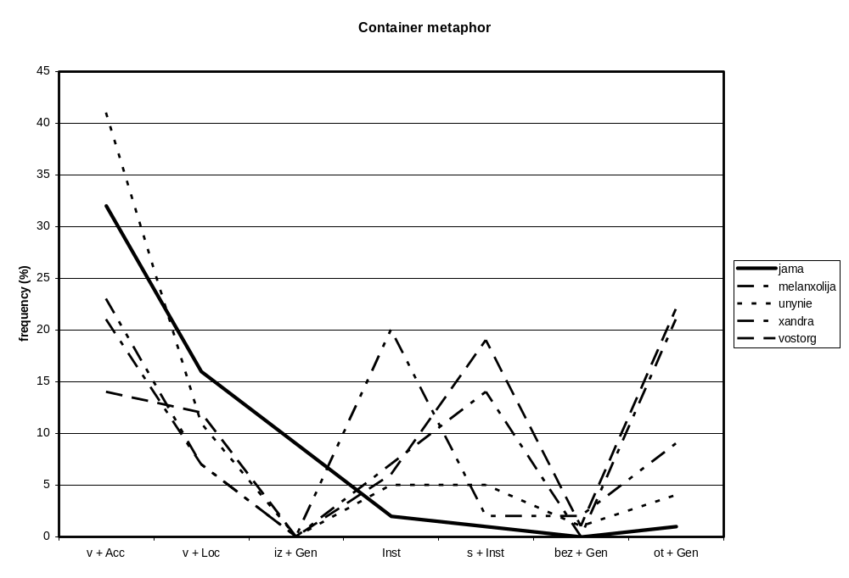
Jama ‘hole, pit’ is a source domain noun, providing a standard for comparing the target domain emotion words. Three constructions are most relevant in the constructional profile of jama ‘hole, pit’: v + Acc ‘into’ with the highest value, v + Loc ‘in’ with an intermediate value, and iz + Gen ‘out of’ with a lower value, but one that by far exceeds all other remaining values. Three ‘sadness’ nouns, melanxolija, unynie, and xandra, show clear parallels in their constructional profiles, with a high peak for v + Acc ‘into’ and a lower but robust value for v + Loc ‘in’. Though these ‘sadness’ nouns show zero percentages for the iz + Gen ‘out of’, this is due to the fact that the frequency was so low that zero was the closest integer. It is possible to metaphorically get out of ‘sadness’, and the RNC contains one such example for each of these three nouns; here is the one with xandra to illustrate:

Ja, k primeru, iz xandry ne vylezaju.
[I-Nom, toward example-Dat, out-of sadness-Gen not climb.]
‘I, for one, am not climbing out of sadness.’

Such isolated examples, however, show us that the iz + Gen ‘out of’ construction, and therefore the associated metaphor, is not conventional for these words. Comparison of constructional profiles shows that only part of the structure associated with a source domain container is conventionally mapped to the target domain of emotions in Russian: getting into a container and being in a container are mapped, but getting out is not mapped. In Russian, a different metaphor is more often used to understand how emotional states are concluded, invoked by the construction ot + Gen ‘away from’. The use of this construction is motivated by its use to describe healing of diseases, and lečit’sja ot bolezni [be-cured away-from disease-Gen] ‘be cured of a disease’ is a conventional expression, itself a metaphor motivated by the physical experience of removal from a location near a landmark. At the clause level the ot + Gen ‘away from’ construction has another interpretation that is also conventional for emotion terms: cause (cf. 2.3.1), and disambiguation of these two options is beyond the scope of this article.
Melanxolija, unynie, and xandra show parallels to the physical container jama ‘hole, pit’ in their frequencies for ‘in/into’ relations, supporting the claim that they are metaphorical containers. The values for these constructions are low, but not zero for the other three ‘sadness’ nouns, suggesting that they are only marginally understood as containers. This pattern contrasts with that of the ‘happiness’ nouns, where, aside from vostorg, we see close to zero evidence of the container metaphor. The other four ‘happiness’ nouns show values of 0% or 1% for both v + Acc ‘into’ and v + Loc ‘in’ with one exception: a 5% value for likovanie in the v + Loc ‘in’ construction. As for vostorg, often translated as ‘rapture, delight’, we see a slightly different pattern. The values for v + Acc ‘into’ and v + Loc ‘in’ are strong, but the difference between them is very small. This different pattern may be due to the fact that whereas jama ‘hole, pit’ and the ‘sadness’ words represent dangerous landmarks, places that one could fall into and be stuck in, the container metaphor for vostorg is probably motivated by a more positive (or at least neutral) physical container, where there is less emphasis placed on getting into the container (since it does not represent danger).

5.2 ‘Sadness’ and the ontological class of processes
There are two interpretations of the s + Inst ‘with’ construction for the ‘sadness’ nouns, one that is fairly rare, and involves understanding the emotion as a companion or opponent, and one that is more common and involves understanding the emotion as a process that is simultaneous with experiences such as seeing, thinking and speaking (see Appendix A). This combination of interpretations makes finding an appropriate source domain noun for comparison more challenging. Here we offer the noun xrap ‘snore’, which has both interpretations, with the first being less frequent (only 1 out of 15 citations in the RNC), as in these examples:

I kak borot’sja s xrapom?
[And how fight with snore-Inst?]
‘So how does one fight (with) a snore?’

Bova spal s xrapom, napominajuščim stony umirajuščego, golova ego svesilas’ s kojki.
[Bova-Nom slept with snore-Inst, reminding-Inst moans-Acc dying-Gen, head-Nom hung from cot-Gen.]
‘Bova slept with a snore reminiscent of the moans of a dying person, his head hung off the side of the cot.’

Graph 9 compares the constructional profile of the noun xrap with that of the ‘sadness’ nouns that show peaks for the s + Inst construction.

Graph 9:
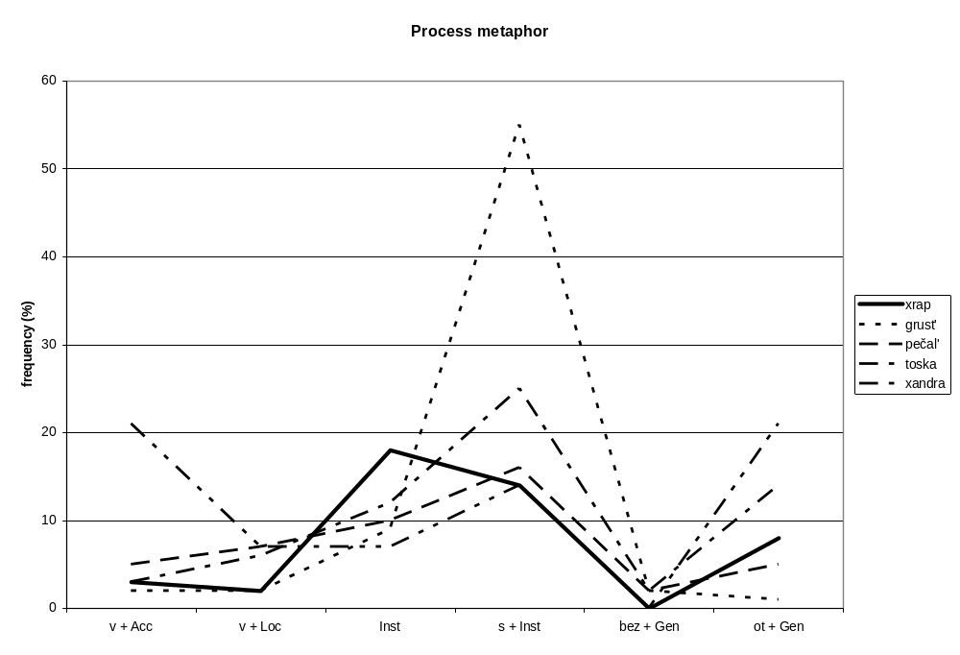

If we ignore the ‘in/into’ relations and focus only on the ‘with/without’ and ‘away’ relations, we see some similarities between xrap ‘snore’ and most of the ‘sadness’ nouns on Graph 9: the strongest values are for Inst, s + Inst, and ot + Gen, and the smallest value is for bez + Gen. However, the relationship between Inst and s + Inst is reversed.
Graph 10 offers another comparison, between melanxolija ‘sadness’ and xrap ‘snore’. The overall shape is somewhat similar, but melanxolija ‘sadness’ shows high frequency for v + Acc ‘into’, whereas the profile for xrap ‘snore’ is negligible; the situation is reversed with the values for s + Inst ‘with’.

Graph 10:
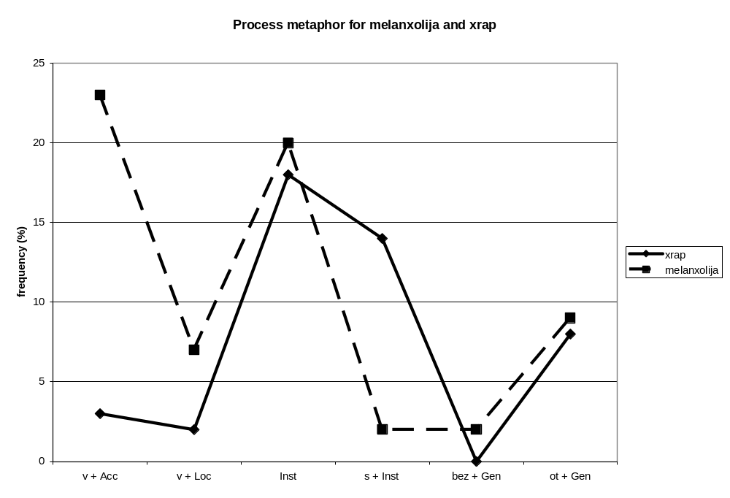

5.3 Correspondences between ontological classes and synonym distance
Section 4 showed that the ‘sadness’ nouns have three different constructional profile patterns, one for grust’, pečal’ and toska, another for melanxolija and xandra, and a third for unynie. By analyzing the connection between constructional profiles and metaphor we can also explore why they are different. Melanxolija, xandra and unynie are metaphorical containers, and among them unynie is most often understood as a container, whereas the other ‘sadness’ terms are only marginally understood as containers. ‘Sadness’ is understood as a metaphorical accompanying process for grust’, pečal’, toska, xandra, and to a lesser extent melanxolija. The ot + Gen construction gives the highest values for xandra, toska, and melanxolija, suggesting that these words for ‘sadness’ liken the emotion either to a disease one can be healed from or a cause for something.

6. Conclusions
This article presents constructional profiles, the relative frequencies of constructions a word appears in, as a possible measure of the word’s meaning. The constructional profile patterns of synonyms are shown to share a small group of constructions that they appear in most frequently, as well as some characteristics of the frequencies. Differences in frequencies correspond to differences in “distance” between synonyms. Constructional profiles largely confirm the introspective judgments of dictionary authors, and in addition pinpoint where the differences among synonyms lie. Antonyms can be shown to share both the sets of constructions they appear in and constructional profile patterns. Random unrelated words share neither property.
For abstract nouns such as emotion terms, the constructional profile patterns are at least partly related to the conceptual metaphors most conventional for the terms. The metaphorical understanding of emotion terms involves the range of source domains and ontological classes they invoke. Constructional profile patterns show that Russian ‘sadness’ terms are understood as metaphorical containers, processes, companions/opponents, diseases and causes. It is possible to compare the constructional profiles of source domain nouns with those of target domain nouns such as emotion terms.
Constructional profiles offer insights into metaphor and how it affects the meanings and uses of nouns. In an introspective analysis of the container metaphor for Russian ‘sadness’ terms, one might have noticed that ‘sadness’ terms can occur in all relevant constructions, namely v + Acc ‘into’, v + Loc ‘in’ and iz + Gen ‘out of’. However, one would miss some important information that is readily apparent in the constructional profiles: a) the first construction is consistently the most frequent, b) only the first two constructions are conventional, and c) this pattern of frequencies parallels the pattern found in the concrete source domain, where a real container such as jama ‘hole, pit’ appears most frequently in the v + Acc ‘into’ construction, less frequently v + Loc ‘in’, followed by a still lower frequency for iz + Gen ‘out of’. Thus the use of constructions relevant to a metaphor is not uniform in either the source or the target domain. Furthermore, the strength of use of a given relevant metaphor can vary: some Russian ‘sadness’ terms are clearly understood as containers, whereas this metaphor is likely marginal for others.
Finally, constructional profiles demonstrate how the metaphorical understanding of a given abstract noun can be multiply motivated. In other words, a given abstract noun can be understood in terms of several metaphors, and this is reflected in the data. The pattern of metaphorical motivation, in terms of the selection of source domain ontological classes and their relative “strength” differs from one abstract noun to another. This interaction of multiple metaphors may be the reason why it is sometimes difficult to pinpoint a precise source domain motive for some conceptual metaphors (cf. the discussion of processes above).
In sum, constructional profiles lend empirical support to many basic assumptions of cognitive linguistics concerning the relations of syntax and semantics and metaphor, while offering us a more precise view of these mechanisms.

Appendix A: Corpus examples of relevant constructions
The constructions most relevant to this study are illustrated below with examples from the RNC, using the six words for ‘sadness’ that form the core of our study, all glossed simply as ‘sadness’ here. The constructions are underlined in the examples and glosses.

v + Acc ‘into’:

Nesmotrja na saxarnuju bolezn’, on soxranjal ešče umstvennye sposobnosti, no smert’ blizkix ljudej povergla ego v krajnjuju grust’.
[Not-looking on sugar disease-Acc, he retained still mental faculties-Acc, but death-Nom near people-Gen cast him-Acc in extreme sadness-Acc.]
‘In spite of his diabetes, he continued to retain all his mental faculties, but the death of people near to him cast him into extreme sadness.’

In principle, the v + Acc ‘into’ construction is polysemous, signaling destinations (often metaphorical), factors in multiplication, days and hours when events take place, durations, size and capacity, games. However, most of these uses are lexically restricted to nouns such as names of days, games, and numerals, and none of these are relevant for our study. The one use that is relevant is the one illustrated in the example, namely the destination use, which identifies the destination as a container.

v + Loc ‘in’:

Ej na um ne pridet, čto suprug iznyvaet v toske o poterjannyx minutax truda i vdoxnovenija.
[Her-Dat on mind-Acc not comes, that spouse-Nom pines-away in sadness-Loc about lost minutes-Loc labor-Gen and inspiration-Gen.]
‘It doesn’t occur to her that her spouse is suffering in sadness over the minutes of work and inspiration that he has lost.’

The v + Loc ‘in’ construction unambiguously refers to location in a container, be it physical or metaphorical.

Inst (bare Instrumental):

This construction is polysemous, but the uses relevant to our study fall under the umbrella of a means, realized in slight variations as illustrated by the four examples below.

Kto iz živuščix, tomimyj unyniem, ne predavalsja takomu pereboru ne sostojavšixsja žiznennyx variantov?
[Who-Nom from living-Gen, tormented sadness-Inst, not indulged such inventory-Dat not happened life’s variants-Gen?]
‘Who among mortals tormented by sadness, has not indulged in an inventory of all the things that didn’t happen in their life?’

This example illustrates the use of the instrumental to describe a means (or metaphorical agent) in the presence of a passive participle such as tomimyj ‘tormented’. Reflexive passives are also found in combination with this use of the bare Instrumental construction as we see in the following example:

Vesel’e ot vospominanij o škol’nyx prokazax smenjaetsja grust’ju po ušedšim godam.
[Joy-Nom from memories-Gen about school pranks-Loc replaces-refl sadness-Inst along departed years-Dat.]
‘Joy from memories of schoolroom pranks is replaced by sadness over the years gone by.’

The bare Instrumental construction participates in another larger construction that is very similar to the passives above, but differs in that there is no Nominative subject involved and that the Instrumental can only mark a means (no clear agent can be named; cf. Smith 1994, Janda forthcoming). This use is often referred to as the “raw force” Instrumental (Janda & Clancy 2002: 37) and is associated with calamities and natural phenomena such as smells, as in this example:

V serom kolorite ètix kartin mnogo ottenkov, i ot vsex nix veet zastareloj toskoj i bezysxodnost’ju.
[In gray color-Loc those pictures-Gen many-Nom hues-Gen, and from all them-Gen wafts chronic sadness-Inst and despair-Inst.]
‘There were many hues in the gray color of those pictures, and a whiff of chronic sadness and despair came from all of them.’

The effect of this construction is that a smell is effected by means of sadness and despair, a metaphorical version of the physical experience encoded by the same construction in expressions like zdes’ paxnet česnokom [here smells garlic-Inst] ‘it smells of garlic here’.

Less frequently the bare instrumental marks objects of the verb, here understood as the means through which the verbal action takes place. With emotion terms this is possible with verbs that involve possession and manipulation, such as podelit’sja ‘share’ as in this example:

Na sledujuščij den’, v svetlyj prazdnik Pervogo maja, pobityj Roma postučal ko mne i podelilsja svoej pečal’ju.
[On next day-Acc, in light holiday-Acc First-Gen May-Gen, beaten-up Roma-Nom knocked to me-Dat and shared own sadness-Inst.]
‘The next day, on the cheerful holiday of the First of May, Roma came, all beaten up, knocked on my door and shared his sadness.’

Sadness here serves as the means by which the action of sharing takes place.
Another infrequent but relevant use of the bare Instrumental identifies a label, the means by which something can be categorized.

Ved’ pereživaemye segodnja Rossiej smutnaja nostal’gija i paternalistskie nastroenija vovse ne javljajutsja toskoj po konkretnoj sovetskoj vlasti, kakoj ee pomnit bol’šinstvo nacii.
[Actually experienced-Nom today Russia-Inst sorrowful nostalgia-Nom and paternalistic moods-Nom entirely not are sadness-Inst along concrete Soviet autority-Dat, which-Dat it-Acc remember majority-Nom kation-Gen.]
‘As a matter of fact, the sorrowful nostalgia and paternalistic attitudes that Russia is experiencing today are not at all (a kind of) sadness over the actual Soviet authority as it is remembered by the majority of the nation.’

In other words, the issue here is whether the nostalgia and attitudes can be labeled using the category toska ‘sadness’.
Given that this study focuses on the level of the noun phrase construction, the minor differences between the interpretation of this construction at the clausal level are not disambiguated. Disambiguation would at any rate require subjective value judgments of the kind that our study is designed to avoid.

s + Inst ‘with’:
This construction signals companions or other peripheral accessories that accompany a person or their actions, though it cannot be used for instruments (for which the bare Instrumental is required). In some uses an abstract noun is clearly understood as a metaphorical companion or opponent, as in this example:

Poprobuj, sladim li s prokljatoju xandroj.
[Try, deal if with accursed sadness-Inst.]
‘Let’s see if we can work things out with this accursed sadness.’

However, this kind of use is fairly rare with Russian emotion terms. More often the s + Inst ‘with’ construction is used to signal an accessory to an action, something that accompanies what a person is doing, as in this example:

Ox, smertyn’ka moja prixodit, podumal Arefa s unyniem.
[Oh, death mine-Nom approaches, thought Arefa-Nom with sadness-Inst.]
‘Oh, my death is approaching, thought Arefa with sadness.’

Again, our study does not disambiguate these uses, which are very close.

bez + Gen ‘without’:
This use of the Genitive is motivated by both a negative quantity (where quantification comes from the part-whole relationship of the Genitive) and point of reference (where the Genitive entity is something that another entity is separated from). In a very real sense, this construction expresses the antonym of the predominant use of the s + Inst ‘with’ construction, as we see in this example:

Rasskazyvala Nexaeva medlenno, vpolgolosa, no – bez pečali, i èto bylo stranno.
[Told Nexaeva-Nom slowly, half-voice, but – without sadness-Gen, and that-Nom was strange.]
‘Nexaeva told the story slowly, in a low voice, but – without sadness, and that was strange.’

ot + Gen ‘away from’:
This construction highlights the meaning of separation from a source, and stands in a metonymical relationship with the previous construction because ot + Gen ‘away from’ signals a path in relation to which bez + Gen ‘without’ signals only the endpoint. In the presence of the Russian ‘sadness’ nouns, three somewhat overlapping uses can be recognized. The first is directly motivated by physical motion away from something, such as ot okna [from window-Gen] ‘away from the window’, as in this example:

Utrom ja bodr i inogda daže vesel, no k noči ne znaju, kuda det’sja ot xandry.
[Morning-Inst I-Nom energetic and sometimes even cheerful, but towards night-Dat not know, where go from sadness-Gen.]
‘In the morning I am energetic and sometimes even cheerful, but toward evening I don’t know where to run to get away from the sadness.’

The second use often refers to healing as a metaphorical process involving separation from a disease:

Samoe lučšee lekarstvo ot xandry èto čtenie.
[The best medicine-Nom from sadness-Gen that reading-Nom.]
‘The best cure for sadness is reading.’

The third use invokes the domain of purpose and cause, where the Genitive entity is the metaphorical source for something, thus causing an event, as in this example:

Podumajte, ètot čelovek umer ot melanxolii!
[Think, that person-Nom died from sadness-Gen!]
‘Just imagine, that person died of sadness!’

To sum up, the following constructions are most relevant to our study. A noun in v + Acc ‘into’ and/or v + Loc ‘in’ constructions can be understood as a container. A noun can also signal an instrument or means (Inst), or can be something that one is ‘with’ (s + Inst) or ‘without’ (bez + Gen). The corresponding construction for leaving a container (iz + Gen ‘out of’) is not robustly attested for the ‘sadness’ nouns. Instead, removal from ‘sadness’ is presented in terms of removal from a proximal location, which can metaphorically be interpreted as healing or cause.

Appendix B: Constructional profile data from corpus study
For each noun, the first column gives the total raw frequency, and other columns list percentages relative to that total.

‘Sadness words’
Number of instances | v + Acc | v + Loc | Inst | s + Inst | bez + Gen | ot + Gen | Acc | other Cs
grust' 290 | 2 | 2 | 9 | 55 | 2 | 1 | 17 | 11
melanxolija 227 | 23 | 7 | 20 | 2 | 2 | 9 | 14 | 23
pečal' 315 | 5 | 7 | 10 | 16 | 2 | 5 | 41 | 15
toska 283 | 3 | 6 | 12 | 25 | 2 | 14 | 30 | 10
unynie 304 | 41 | 11 | 5 | 5 | 1 | 4 | 8 | 26
xandra 140 | 21 | 7 | 7 | 14 | 0 | 21 | 14 | 16

‘Happiness words’
Number of instances | v + Acc | v + Loc | Inst | s + Inst | bez + Gen | ot + Gen | Acc | other Cs
likovanie 392 | 1 | 5 | 10 | 23 | 0 | 2 | 44 | 15
naslaždenie 291 | 0 | 1 | 4 | 40 | 0 | 3 | 38 | 13
radost' 285 | 0 | 0 | 7 | 32 | 1 | 14 | 37 | 7
udovol'stvie 407 | 0 | 1 | 1 | 41 | 5 | 6 | 42 | 5
vostorg 304 | 14 | 12 | 6 | 19 | 1 | 22 | 22 | 5

Utka ‘duck’
 | Number of instances | v + Acc | Inst | s + Inst | Dat | na + Acc | Acc | other Cs
utka | 372 | 4 | 6 | 4 | 4 | 6 | 66 | 9

Mečta ‘dream’
Number of instances | v + Acc | v + Loc | Inst | s + Inst | bez + Gen | ot + Gen | Acc | other Cs
mečta 345 | 3 | 12 | 10 | 4 | 0 | 1 | 50 | 18

Jama ‘hole, pit’
Number of instances | v + Acc | v + Loc | iz + Gen | Inst | s + Inst | bez + Gen | ot + Gen | Acc | other Cs
jama 274 | 32 | 16 | 9 | 2 | 1 | 0 | 1 | 30 | 8

Xrap ‘snore’
Number of instances | v + Acc | v + Loc | Inst | s + Inst | bez + Gen | ot + Gen | Acc | other Cs
xrap 229 | 3 | 2 | 18 | 14 | 0 | 8 | 36 | 18

Works cited

Aleksandrova, Zinaida E. 1989. Slovar’ sinonimov russkogo jazyka. Moscow: Russkij jazyk.
Apresjan, Jurij D. 1974. Leksičeskaja semantika: sinonimičeskie sredstva jazyka. Moscow: Nauka.
Apresjan, Jurij D. 1993. “Metafora v leksografičeskom tolkovanii èmocij.” Voprosy jazykoznanija 3, 27-35.
Apresjan, Jurij D. 1995. Leksičeskaja semantika: Sinonimičeskie sredstva jazyka. Moskva: Jazyki russkoj kul’tury.
Apresjan, Jurij D. et al. 1997. Novyj ob”jasnitel’nyj slovar’ sinonimov russkogo jazyka. Vyp. 1. Moscow: Jazyki russkoj kul’tury.
Arutjunova, Nina D. 2007. Predloženie i ego smysl. Moscow: URSS.
Atkins, Beryl T. S. 1987. “Semantic ID tags: corpus evidence for dictionary senses.” Proceedings of the Third Annual Conference of the UW Centre for the New Oxford English Dictionary, 17-36.
Barðdal, Johanna. 1999. “Case in Icelandic – a construction grammar approach”, Tijdschrift voor Skandinavistiek 20: 65-100.
Barðdal, Johanna. 2006. “Construction-specific properties of syntactic subjects in Icelandic and German”, Cognitive Linguistics 17: 39–106.
Blake, Barry J. 1994. Case. Cambridge. Cambridge U Press.
Budanitsky, Alexander and Graeme Hirst. 2006. “Evaluating WordNet-based Measurs of Lexical Semantic Relatedness.” Computational Linguistics 32, 13-47.
Burgess, C., K. Livesay and K. Lund. 1998. “Explorations in context space: Words, sentences, discourse.” Discourse Processes 25, 211-257.
Bybee, Joan and Paul Hopper 2001. “Introduction to Frequency and the Emergence of Linguistic Structure,” in Bybee, Joan and Paul Hopper, eds. Frequency and the Emergence of Linguistic Structure. Amsterdam: Benjamins, 1-26.
Churchland, Paul M. 1995. The Engine of Reason, the Seat of the Soul: A Philosophical Journey into the Brain. Cambridge, Mass.: MIT Press.
Clark, Eve V. 1993. The Lexicon in Acquisition. Cambridge: Cambridge U Press.
Croft, William. 2001. Radical Construction Grammar. Oxford: Oxford U Press.
Croft, William and D. Alan Cruse. 2004. Cognitive Linguistics. Cambridge: Cambridge U Press.
Dąbrowska, Ewa. 2004. Language, Mind and Brain. Edinburgh: Edinburgh U Press.
Dagan, Ido. 2000. “Contextual word similarity”, in Robert Dale, Hermann Moisl and Harold Somers, eds., Handbook of Natural Language Processing. New York: Marcel Dekker, 459-475.
Divjak, Dagmar. 2006. “Ways of intending: Delineating and structuring near-synonyms”, in Stefan Gries and Anatol Stefnaowitsch, eds., Corpora in Cognitive Linguistics, v. 2: The Syntax-Lexis Interface. Berlin: Mouton de Gruyter, 19-56.
Divjak, Dagmar and Stefan Th. Gries. 2006. “Ways of trying in Russian: clustering behavioral profiles”, Corpus Linguistics and Linguistic Theory, 23-60.
Divjak, Dagmar and Laura A. Janda. Forthcoming. “Ways of attenuating agency in Russian”, in Impersonal Constructions, a special issue of Transactions of the Philological Society, edited by Anna Siewierska.
Dziwirek, Katarzyna. Forthcoming. “A folk classification of Polish emotions: Evidence from a Corpus-Based Study”.
Dziwirek, Katarzyna and Barbara Lewandowska-Tomaszczyk. 2003. “Syntax and Semantics of Polish and English Expressions of Emotions: A Corpus Study”. AATSEEL conference presentation.
Evgen’eva, A. P., ed. 2001. Slovar’ sinonimov russkogo jazyka. Moscow: Astrel’.
Feldman, Jerome A. 2006. From Molecule to Metaphor: A Neural Theory of Language. Cambridge, MA: MIT Press.
Fillmore, Charles. 1982. “Frame semantics”, in Linguistic Society of Korea, ed. Linguistics in the Morning Calm. Seoul: Hanshin Publishing, 111-137.
Fillmore, Charles. 1985. “Syntactic intrusions and the notion of grammatical construction”, Proceedings of the Berkeley Linguistics Society 11, 73-86.
Fillmore, Charles J., Paul Kay, Laura Michaelis, and Ivan Sag. Forthcoming. Construction Grammar. Stanford, CA: CSLI Publications.
Firth, John R. 1957. A synopsis of linguistic theory 1930-1955. In Philological Society, eds., Studies in Linguistic Analysis. Oxford: Blackwell, 1-32.
Fried, Mirjam. 2005. “A frame-based approach to case alternations: The swarm-class verbs in Czech”, Cognitive Linguistics 16: 475–512.
Geeraerts, Dirk. 2005. “Lectal variation and empirical data in Cognitive Linguistics.” In Francisco J. Ruiz de Mendoza Ibáñez and M. Sandra Peña Cervel, eds. Cognitive Linguistics: Internal Dynamics and Interdisciplinary Interaction (= Cognitive Linguistics Research 32). Berlin: Mouton de Gruyter, 163-189.
Gilquin, Gaëtanelle. 2007a. “ To err is not all. What corpus and elicitation can reveal about the use of collocations by learners.” Zeitschrift für Anglistik und Amerikanistik, 273-292.
Gilquin, Gaëtanelle. 2007b. “The cognitive reality of frequent verb-noun combinations: An empirical study.” presentation at ICLC, Krakow, Poland.
Goldberg, Adele. 1995. Constructions: A Construction Grammar Approach to Argument Structure. Chicago: Chicago U Press.
Goldberg, Adele. 2006. Constructions at Work: The Nature of Generalizations in Language. Oxford: Oxford U Press.
Gries, Stefan Th. and Dagmar S. Divjak. forthcoming. Behavioral profiles: a corpus-based approach towards cognitive semantic analysis. In: Evans, Vyvyan and Stephanie S. Pourcel (eds.). New directions in cognitive linguistics. Amsterdam, Philadelphia: John Benjamins.
Hanks, Patrick. 1996. Contextual dependency and lexical sets. International Journal of Corpus Linguistics 1 (1), 75-98.
Ide, Nancy and Jean Véronis. 1998. “Introduction to the Special Issue on Word Sense Disambiguation: The state of the art”. Computational Linguistics 24, 1-40.
Janda, Laura A. 1993. A Geography of Case Semantics: The Czech Dative and the Russian Instrumental (=Cognitive Linguistics Research, v. 4). Berlin: Mouton de Gruyter.
Janda, Laura A. 1999. “Peircean semiotics and cognitive linguistics: a case study of the Russian genitive”, in The Peirce Seminar Papers, ed. by Michael Shapiro. New York/Oxford: Berghahn Books, 441-466.
Janda, Laura A. 2000. “A cognitive model of the Russian accusative case,” in Trudy meždunarodnoj konferencii Kognitivnoe modelirovanie, No. 4, part I, ed. by R. K. Potapova, V. D. Solov’ev and V. N. Poljakov. Moscow: MISIS, 20-43.
Janda, Laura A. 2002a. “Cases in collision, cases in collusion: the semantic space of case in Czech and Russian”, in Where One’s Tongue Rules Well: A Festschrift for Charles E. Townsend, ed. by Laura A. Janda, Steven Franks, and Ronald Feldstein. Columbus, Ohio: Slavica, 43-61.
Janda, Laura A. 2002b. “Cognitive hot spots in the Russian case system”, in Michael Shapiro, ed. Peircean Semiotics: The State of the Art (=The Peirce Seminar Papers 5). New York: Berghahn Books, 165-188.
Janda, Laura A. 2002c. “The Case for Competing Conceptual Systems”, in Cognitive Linguistics Today (= Łódź Studies in Language 6), ed. by Barbara Lewandowska-Tomaszczyk and Kamila Turewicz, Frankfurt: Peter Lang, 355-374.
Janda, Laura A. 2002d. “Concepts of Case and Time in Slavic”, in Glossos 3 at http://www.seelrc.org/glossos/.
Janda, Laura A. 2004. “Border zones in the Russian case system”, in Sokrovennye smysly, ed. by Ju. D. Apresjan. Moscow: Jazyki slavjanskoj kul’tury, 378-398.
Janda, Laura A. Forthcoming. “Transitivity in Russian from a Cognitive Perspective”, in a festschrift for Elena Viktorovna Paducheva entitled Dinamičeskie modeli: Slovo. Predloženie. Tekst, edited by Galina Kustova. Moscow: Jazyki slavjanskoj kul’tury.
Janda, Laura A. and Steven J. Clancy. 2002. The Case Book for Russian. Bloomington, IN: Slavica.
Johnson, Mark. 1987. The Body in the Mind. Chicago/London: U of Chicago Press.
Kay, Paul and Charles J. Fillmore. 1999. “Grammatical constructions and linguistic generalizations: the what’s X doing Y? construction”, Language 75: 1-34.
Kempe, Vera and Brian MacWhinney. 1999. “Processing of morphological and semantic cues in Russian and German.” Language and Cognitive Processes 14: 129-171.
Kilgarriff, Adam. 1997. “I don't believe in word senses”. Computers and the Humanities 31, 91-113.
Kobricov, B. P. 2004. “Metody snjatija semantičeskoj neodnoznačnosti”, NTI Ser. 2, Vyp. 3, 1-30.
Kövecses, Zoltán. 2001. Metaphor and Emotion: Language, Culture, and Body in Human Feeling. Cambridge: Cambridge U Press.
Lakoff, George. 1987. Women, Fire and Dangerous Things. Chicago: Chicago U Press.
Lakoff, George. 1990. The Invariance Hypothesis: Is Abstract Reasoning Based Image-Schemas? Cognitive Linguistics 1(1): 39-74.
Lakoff, George and Mark Johnson. 1980. Metaphors We Live By. Chicago: Chicago U Press.
Landauer, T. K., P.W. Foltz and D. Laham. 1998. “Introduction to Latent Semantic Analysis”. Discourse Processes, 259-284.
Langacker, Ronald W. 1987. Foundations of Cognitive Grammar, vol. 1. Theoretical Prerequisites. Stanford: Stanford U Press.
Langacker, Ronald W. 1990. Concept, Image, and Symbol: The Cognitive Basis of Grammar. Berlin/New York: Mouton de Gruyter.
Langacker, Ronald W. 1991. Foundations of Cognitive Grammar II. Stanford, CA: Stanford U Press.
Langacker, Ronald W. 2003. “Constructional integration, grammaticization, and serial verb constructions”, Language and Linguistics 4, 251-278.
Levontina, Irina B. and Anna A. Zalizniak. 2001. “Human emotions viewed through the Russian language”. In Harkins, Jean and Anna Wierzbicka, eds. Emotions in Crosslinguistic Perspective (= Cognitive Linguistics Research 17). Berlin: Mouton de Gruyter, 291-336.
MacWhinney, Brian. 2001. “Emergentist approaches to language,” in Bybee, Joan and Paul Hopper, eds. Frequency and the Emergence of Linguistic Structure. Amsterdam: Benjamins, 449-.
Mel’čuk, Igor’ A. 2001. Communicative organization in natural language: the semantic-communicative structure of sentences. Amsterdam: J. Benjamins.
Mostovaja, Anna D. 1998. “On emotions that one can ‘immerse into’, ‘fall into’ and ‘come into’: the semantics of a few Russian prepositional constructions”. in Athanasiadou, Angeliki and Elżbieta Tabakowska, eds. Speaking of Emotions: Conceptualisation and Expression (= Cognitive Linguistics Research 10). Berlin: Mouton de Gruyter, 295-329.
Radden, Günter. 1998. “The conceptualization of emotion causality by means of prepositional phrases”. in Athanasiadou, Angeliki and Elżbieta Tabakowska, eds. Speaking of Emotions: Conceptualisation and Expression (= Cognitive Linguistics Research 10). Berlin: Mouton de Gruyter, 273-294.
Raxilina, Ekaterina V. 2000. Kognitivnyj analiz predmetnyx imen. Moscow: Russkie slovari.
Schmid, Hans-Jörg. 2000. English Abstract Nouns as Conceptual Shells. (= Topics in English Linguistics 34). Berlin: Mouton de Gruyter.
Schmid, Hans-Jörg. 2007. “Does frequency in text really instantiate entrenchment in the cognitive system?” presentation at ICLC in Krakow, Poland.
Schmid, Hans-Jörg. forthcoming. “Entrenchment, salience and basic levels”, in: Dirk Geeraerts and Hubert Cuyckens, eds. Handbook of Cognitive Linguistics, Oxford: Oxford University Press.
Smith, Michael B. 1994. “Agreement and iconicity in Russian Impersonal Constructions”. Cognitive Linguistics 5, 5-56.
Smith, Laurence D., Lisa A. Best, D. Alan Stubbs, Andrea A. Archibald and Roxann Roberson-Nay. 2002. Constructing knowledge: The role of graphs and tables in hard and soft psychology. American Psychologist 57, 749-761.
Stefanowitsch, Anatol. 2006. Corpus-based approaches to metaphor and metonymy. In Anatol Stefanowitsch and Stefan Th. Gries (eds), Corpus-based Approaches to Metaphor and Metonymy (Trends in Linguistics 171), 1-16. Berlin and New York: Mouton de Gruyter.
Stefanowitsch, Anatol. 2006. Words and their metaphors: A corpus-based approach. In Anatol Stefanowitsch and Stefan Th. Gries (eds), Corpus-based Approaches to Metaphor and Metonymy (Trends in Linguistics 171), 61-105. Berlin and New York: Mouton de Gruyter.
Stefanowitsch, Anatol and Stefan Th. Gries. 2003. “Collostructions: Investigating the interaction of words and constructions”. International Journal of Corpus Linguistics 8: 209-243.
Stefanowitsch, Anatol and Stefan Th. Gries. 2005. “Covarying collexemes”. Corpus Linguistics and Linguistic Theory 1: 1-43.
Svanlund, Jan. 2007. “Metaphor and convention.” Cognitive Linguistics 18, 47-89.
Taylor, John R. 2002. Cognitive Grammar. Oxford: Oxford U Press.
Turney, Peter D. 2002. “Mining the Web for Synonyms: PMI-IR versus LSA on TOEFL” Proceedings of the Twelfth European Conference on Machine Learning, 491-502.
Turney, Peter D. 2005. Measuring Semantic Similarity by Latent Relational Analysis. Proceedings of International Joint Conference on Artificial Intelligence, 1136-1141.
Wierzbicka, Anna. 1998. “‘Sadness’ and ‘anger’ in Russian: The non-universality of the so-called ‘basic human emotions’”. in Athanasiadou, Angeliki and Elżbieta Tabakowska, eds. Speaking of Emotions: Conceptualisation and Expression (= Cognitive Linguistics Research 10). Berlin: Mouton de Gruyter, 3-28.
Wierzbicka, Anna. 1999. Emotions across Languages and Cultures: Diversity and Universals. Cambridge: Cambridge U Press.

Data sources:
Biblioteka Moškova. http://aot.ru. 2003.
Nacional’nyj korpus russkogo jazyka. http://ruscorpora.ru. 2005.

Some indeclinable nouns, such as kino ‘cinema’ constitute an exception to this rule, though all numerals, adjectives, determiners and pronouns that modify such nouns bear the appropriate case marking. This indicates that for such nouns case is present, though the entire paradigm may be syncretic.
It should be noted that these differences are calculated against relative frequencies that themselves range between 0%-40%. Even a 6% (the maximum) difference in a parameter of 40% (also the maximum) yields only a 2.4% difference in the overall frequency. Thus the greatest possible deviation is between 37.6% and 40%. For most of the data, this deviation represents only a fraction of a single percentage point.
The role of the bare Accusative is to mark the direct object. However, when a verb is negated, it is possible for the direct object that would otherwise be marked Accusative to bear instead Genitive marking. Since this is an automatic alternation with a clear trigger (the negative particle ne before the verb), there is no point in collecting the data as if it represented two different constructions. For this reason, all data marked as “Acc” (bare Accusative) also includes uses of Genitive marking for direct objects in negated clauses.
This is calculated as (4/70 x 3/69 x 2/68 x 1/67).
Of course the various constructions named on the x-axis constitute a nominal scale presented in an arbitrary order, and thus a bar diagram might be more appropriate. However, since it is easier to visualize comparisons across frequency polygons, and such comparisons are essential to this article, we have chosen to use this type of graph instead.
Note that this assumption goes beyond cognitive linguistics. Cf. Clark’s (1993: 64) “Principle of Contrast”.
It is possible to establish the distance between these six words as distances between points in a multidimensional space where the dimensions correspond to constructions. Here we present results from applying the COSINE formula to the constructional frequency data for the six words. COSINE is one of the most common and frequently used applications for such calculations. For points (x₁,…, x_{n}) and (y₁,…, y_{n}) the distance equals Σx_{i}y_{i} /√((Σ_{i} x_{i}²) (Σ_{i} y_{i}²)). The closer two points are to each other, the closer the number calculated by this formula is to 1. The table shows the distance from unynie to the other words. Table: COSINE distances between unynie and the other ‘sadness’ words grust’pečal’toskamelanxolijaxandraunynie0.320.650.570.790.79 This calculation shows that one could divide these words into two groups, one that is less close to unynie, containing grust’, pečal’, and toska, and another that is closer to unynie, containing melanxolija and xandra. The use of graphs to capture constructional profiles makes these comparisons more visual, and this method of communication has been selected as more appropriate than calculations and tables, in the spirit of Smith et al. 2002.

